# Model2

## Diagram: Model1 Diagram repeated

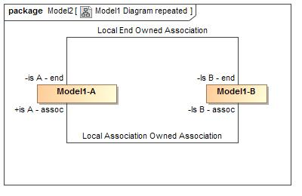

1. Model1 Diagram repeated

## Diagram: Model2

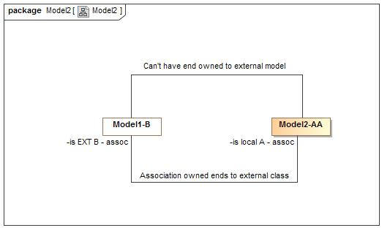

1. Model2

## Class A Composite

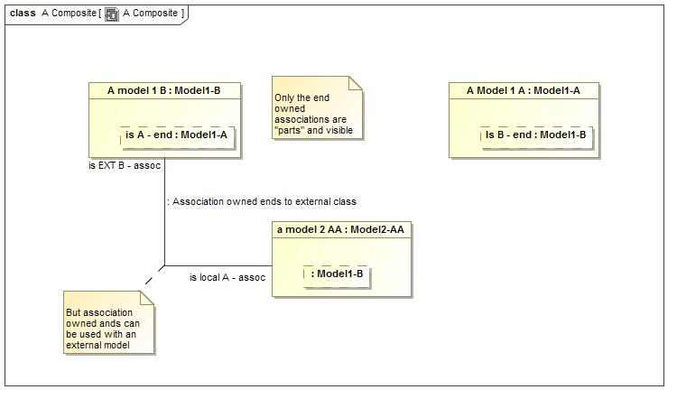

1. A Composite

**package** Model2

### Attributes

-1330737307.jpg a model 2 AA : Model2-AA

-1330737307.jpg A model 1 B : Model1-B

-1330737307.jpg A Model 1 A : Model1-A

## Class Model2-AA

**package** Model2

### Associations

538333861.jpg : Model1-B